**Hibernate & JPA Interview questions**

1. **What is hibernate?**

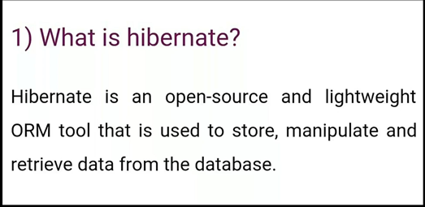



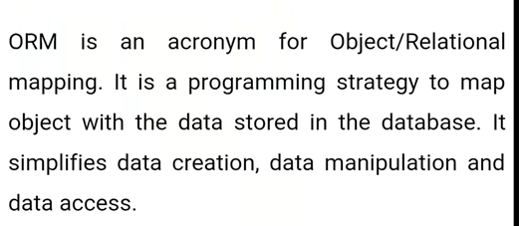

1. **What is hibernate architecture?**

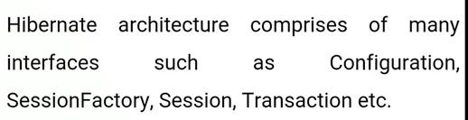

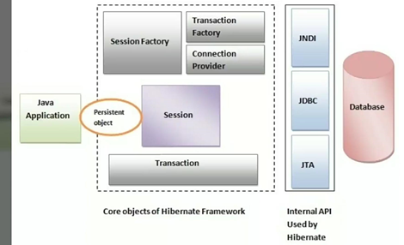

**4) what are the core interfaces of Hibernate?**

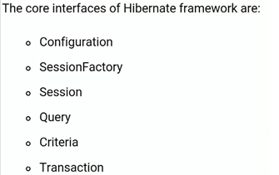

**5) What is Session Factory?**

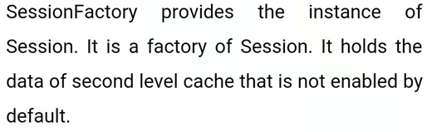

**6)Is session Factory a thread-safe Object**

**Yes, session Factory thread safe object. Multiple can’t access it simultaneously.**

**7) what is a session?**

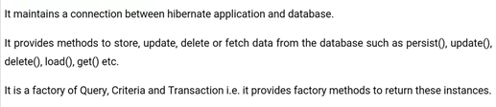

**8)Is session a thread safe object?**

**No, Session is not a thread safe object, many threads can access it simultaneously. In other words, you can share it between threads.**

**9) what Is the difference b/w session.save() and session.persist() method?**

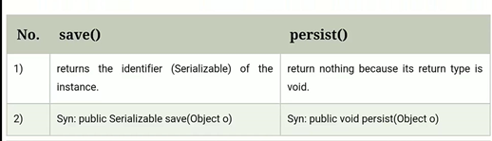

**10)what id diff b/w get and load method?**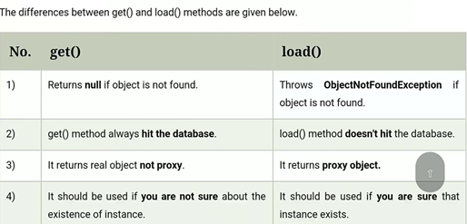

**11) what is the diff b/w update and merge method?**

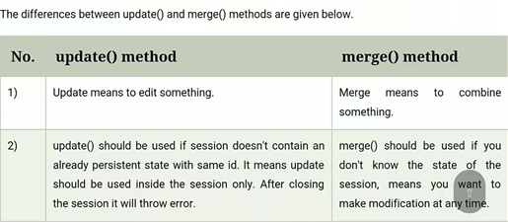

**12)what are the states of object in hibernate**

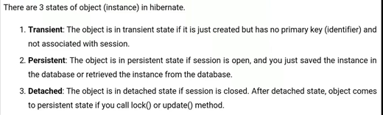

**13)what are the inheritance mapping strategies?**

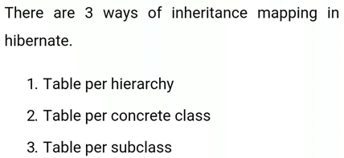

**14)how to make a immutable class in hibernate?**

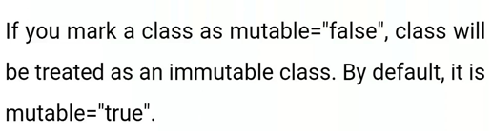

**15)what is automatic dirty checking in hibernate?**

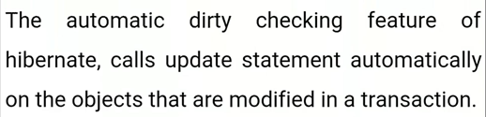

**16) types of possible associate mappings**

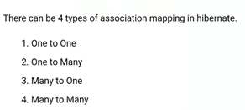

**17) is it possible to perform collection mapping with one-to-one mapping and many to one mapping**

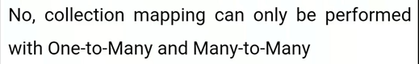

**18)what is lazy loading in hibernate**

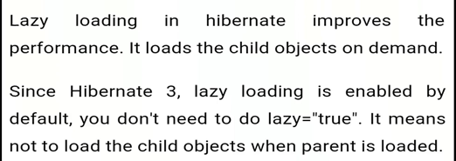

**19) what is HQL**

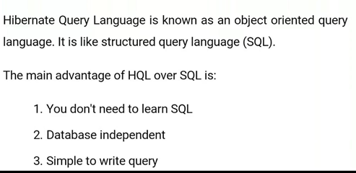

**20) diff b/w first level and second level cache?**

